Search

David Murphy
05 June Growth

App Indexing: The Latest & Greatest in Marketing

App Indexing is Google's answer to the conundrums that face all appreneurs: declining user retention, engagement, and overall loyalty rates.

The buzz surrounding App Indexing lately is, in our opinion, warranted. Essentially, Google’s refined search engine will also include a thumbnail alongside all appropriate results that, when opened, will redirect the browsing user to a pre­ designated screen on your app. If the user does not own your app, then they will instead be redirected onto the app's installation page through the Play Store.

Click the image below for a quick video summary:
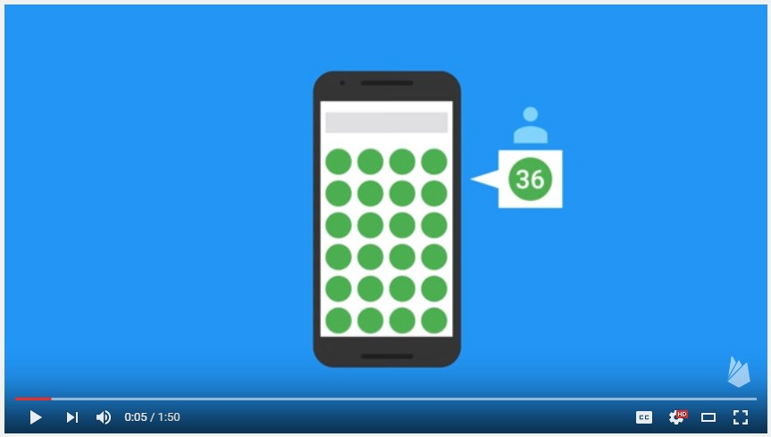
Source: YouTube

Indexing was exclusively available for the Android community until May 2015 when, under the pressure of increasing demand, Google’s team developed and released an API for the iOS platform. Google's product manager even acknowledged the apparent advantages inherent in App Indexing
in a post on Google's official blog:

“With the addition of these install links, we are starting to use App Indexing as a ranking signal for all users on Android, regardless of whether they have your app installed or not”
­ Product Manager at Google, Lawrence Chang

Even though App Indexing has been free and available for both platform developers for over a year,

only 30% of top ranking websites with an Android app and 19% with an iOS have made use of its benefits.

By indexing your app with Google, you’ll be ahead of the marketing curve and better­equipped to contend with some of the highest ranking apps out there. Use App Indexing to your advantage while you still can!

The Discovery of Deep Linking

Standard hyperlinks contain URLs which direct a user to a site’s homepage. Deep links, however, are hyperlinks containing URLs which redirect the user to a particular location or piece of content on a website. The recent development of hyperlinking with apps, however, has allowed developers to redirect users straight to their app from their websites. By deep linking a user to a specific screen on their app, developers bypass the normal amount of input required by users to visit particular content on their app. Taking deep linking to another level, Google hybridized its search engine with app deep linking for the sake of re­engaging users with the previously installed yet forgotten apps on their devices.

on its thumbnail anyway, a deep link to the Google Play store will send them to the app’s particular installation page through the Play Store/App Store instead. This is called deferred deep linking, and it's extremely useful in that it helps both developers and Google by improving the Play Store's traffic and increasing the amount of exposure that indexed apps receive.With another type of redirecting called contextual deep linking, developers can mine information about their users, including where they’re coming from and how they were ultimately converted from a potential user into an actual consumer. Developers use this to re­evaluate their marketing strategy, and to essentially get the most bang for their marketing buck.

How to index your app with Google Search

Getting an app indexed requires implementations into your app's source code and your app's own dedicated website for Google

Search to reference.The process to acquire an index for your app is slightly complex; luckily,

Firebase offers detailed instructions, and different SDKs such as CocoaPods and Branch

equip developers with necessary tools for free.

1. Create support for App Indexing inside the app itself

Acquired by Google, Firebase is a data and service provider that specializes in app development, analytics, and indexing:

For Android...

The process will be much more tedious relative to that of iOS source coding; Google provides the API through their Google Play services, so it's just a matter of implementation. The steps are broken down into fine detail
here.

For iOS…

Firebase suggests that interested developers install the SDK CocoaPods

to help attach the necessary index dependencies into the app’s Xcode project. Again, the process for iOS is much more straightforward compared to android's; more details about debugging and installation are also covered on Firebase’s website here.

2. Test for App Indexing functionality

For Android…

Follow the steps provided here by Google.

For iOS…

A quick search with your app’s URL through Google’s system should suffice.

3. Observe the impact that App Indexing has on your app's growth

000000000000000000000000000000000000000

For Android...

Google provides an optimization service through their Search Console, which has its function rooted in app analytics:

forth. Google’s Search Console focuses on how what happens before someone enters your app. Specifically, if you’ve implemented app indexing, the Search Console will provide you with a ton of data about how users are searching for, finding, and navigating to content inside your app”
­ Mariya moeva, Google’s Webmaster Trends Analyst

Below is a demonstration of Google Search Console’s UI:

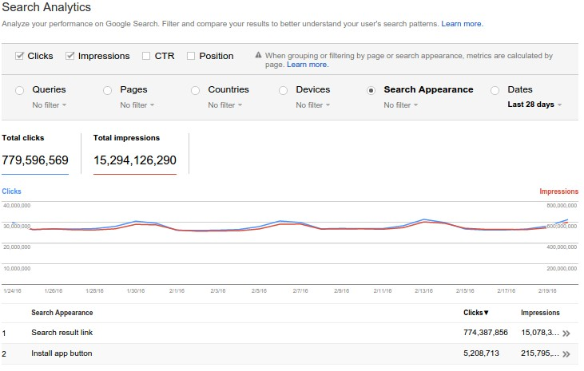

For iOS...

Unfortunately, the Google Search Console is not available for iOS apps:

You can still, however, measure the impact that app indexing has on an iOS app through various methods of analytics: you can start by comparing and contrasting your pre­index user count against your post­index user count.

Branch

Another indexing service, Branch also offers their own open­source SDK. What’s unique about Branch is their original API, which
allows Branch's own development team to monitor and safeguard your app's indexing on a daily basis ­ app indexes need to always be up to code with Google's requirements. Android /iOS

0

You might also like this articles

David Murphy
02 June
Dominick Wojtas
05 December
App Analytics – What can you Únd out
The Importance of Marketing
about your users? The Apple App store offers more than 1million apps for

Successful app optimization is why app analytics is such a profitable investment.

0

the iPhone, iPad and iPod touch in 155 countries around the world. Moreover, there are 950,000 applications available for download on Google Play. There is no denying the high level of competition in the app world. Therefore marketing is vital for the launch of any application; from promotion content for downloads to marketing strategy to keep users active.

0

